**Experiment 4:** write an Arduino program to turn LED ON and OFF using Push Button with Arduino Uno.

**INTERFACING PUSH BUTTON**

**AIM:** To write an Arduino program to turn LED ON and OFF using Push Button with Arduino Uno.

**EQUIPMENTS REQUIRED:**

1. PC

2. Arduino IDE

3. LED

4. Bread Board-1No

5. Resistor-560Ω, 10K Ω -1No

6. Push Button-1No

7. Wires

**CIRCUIT DIAGRAM:**

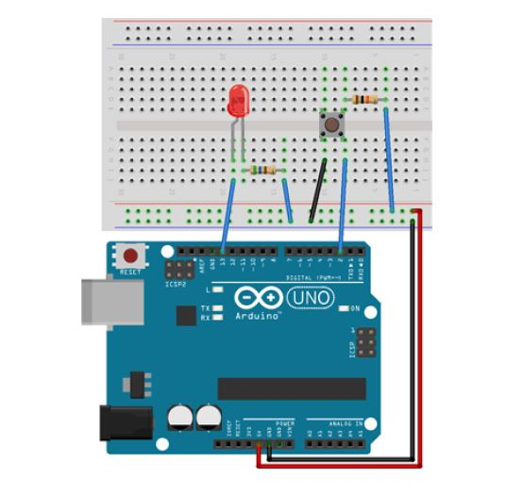

1. Digital pin 13 pin to LED positive
2. Ground (GND) to LED Negative
3. Digital 2 pin to PUSS BUTTON Negative
4. 5V to PUSS BUTTON Negative
5. PUSH BUTTON Positive to LED Negative

**PROCEDURE:**

1. Connect the circuit as per the circuit diagram.

2. Connect Arduino to your PC.

3. Open the Arduino IDE in computer and write the program.

4. Compile the program for any errors and upload it to the Arduino.

5. Observe the output LED ON when pressing Push Button.

**PROGRAM:**

// Turns on and off a light emitting diode(LED) connected to digital

pin 13, when pressing a pushbutton attached to pin 2.

// set pin numbers:

**const int buttonPin = 2;** // the number of the pushbutton pin

**const int ledPin = 13;** // the number of the LED pin // variables will change:

**int buttonState = 0**; // variable for reading the pushbutton status

**void setup() {**

// initialize the LED pin as an output:

**pinMode(ledPin, OUTPUT);**

// initialize the pushbutton pin as an input:

**pinMode(buttonPin, INPUT);**

**}**

**void loop() {**

// read the state of the pushbutton value:

**buttonState = digitalRead(buttonPin);**

// check if the pushbutton is pressed.

// if it is, the buttonState is HIGH:

**if (buttonState == HIGH) {**

// turn LED on:

**digitalWrite(ledPin, HIGH);**

**} else {**

// turn LED off:

**digitalWrite(ledPin, LOW);**

**}**

**}**

**RESULT:** Thus the LED is switched ON, OFF by Push Button using Arduino Uno.